# Introduction:

The goal of this project is to predict the Failure of devices based on different features given in the data.

# What model is the final predictive model?

As the goal is to predict the device failure based on different features given in the dataset, I have trained different machine learning models. The reason behind training and testing different machine learning models is because we want to check which model is more accurate and giving us the highest accuracy. The models I have trained are shown on the below table.

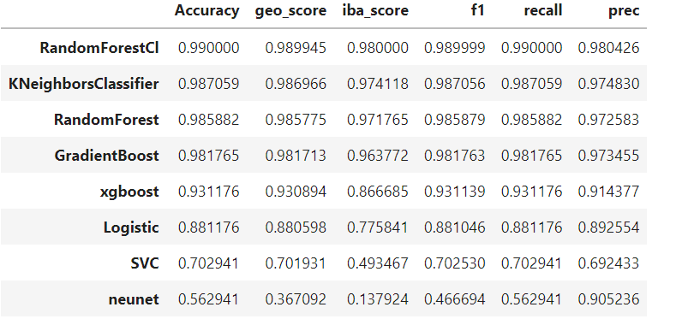

As we can see in the table, we have trained 8 different models, and the highest accuracy was given by the Random Forest model which is 99%, and the smallest accuracy is given by the neunet model. So for our project, the Random Forest model won the race.

# Where is the code of prediction of failure in devices?

The code of predicting the failure in devices in given below, you can check it in the Line 73.

